Instructions for Use – Level 4 Manager

Level 4 – Manager

Used by Training coordinators/POCT leads etc. Can assign users (nurses/staff) courses to be completed and can monitor and track user progress.

Logging in:
Link: https://academy.werfen.com/

Select the “LOGIN” Button.
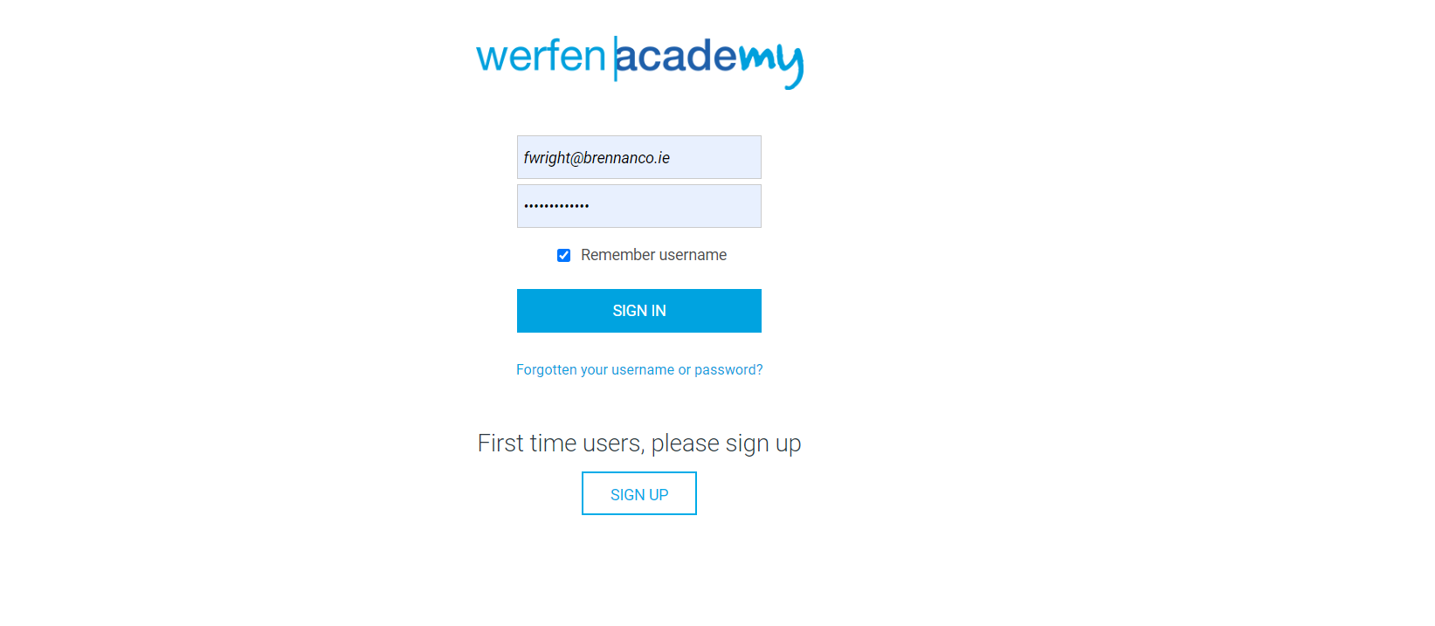
Input your login information.

DASHBOARD

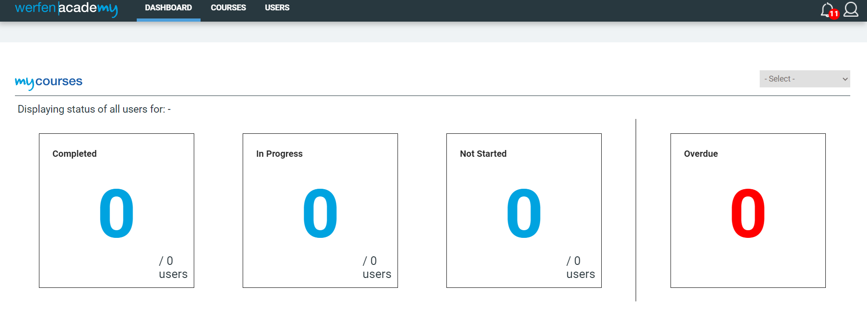
From your dashboard you can view all your own completed and assigned courses.

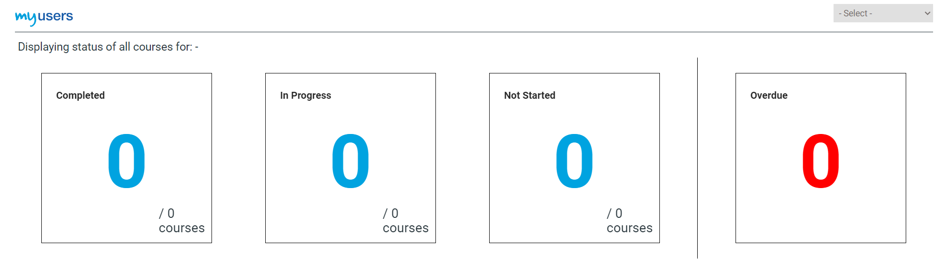
Below, you can also view the status of courses you have assigned to your users.

COURSES
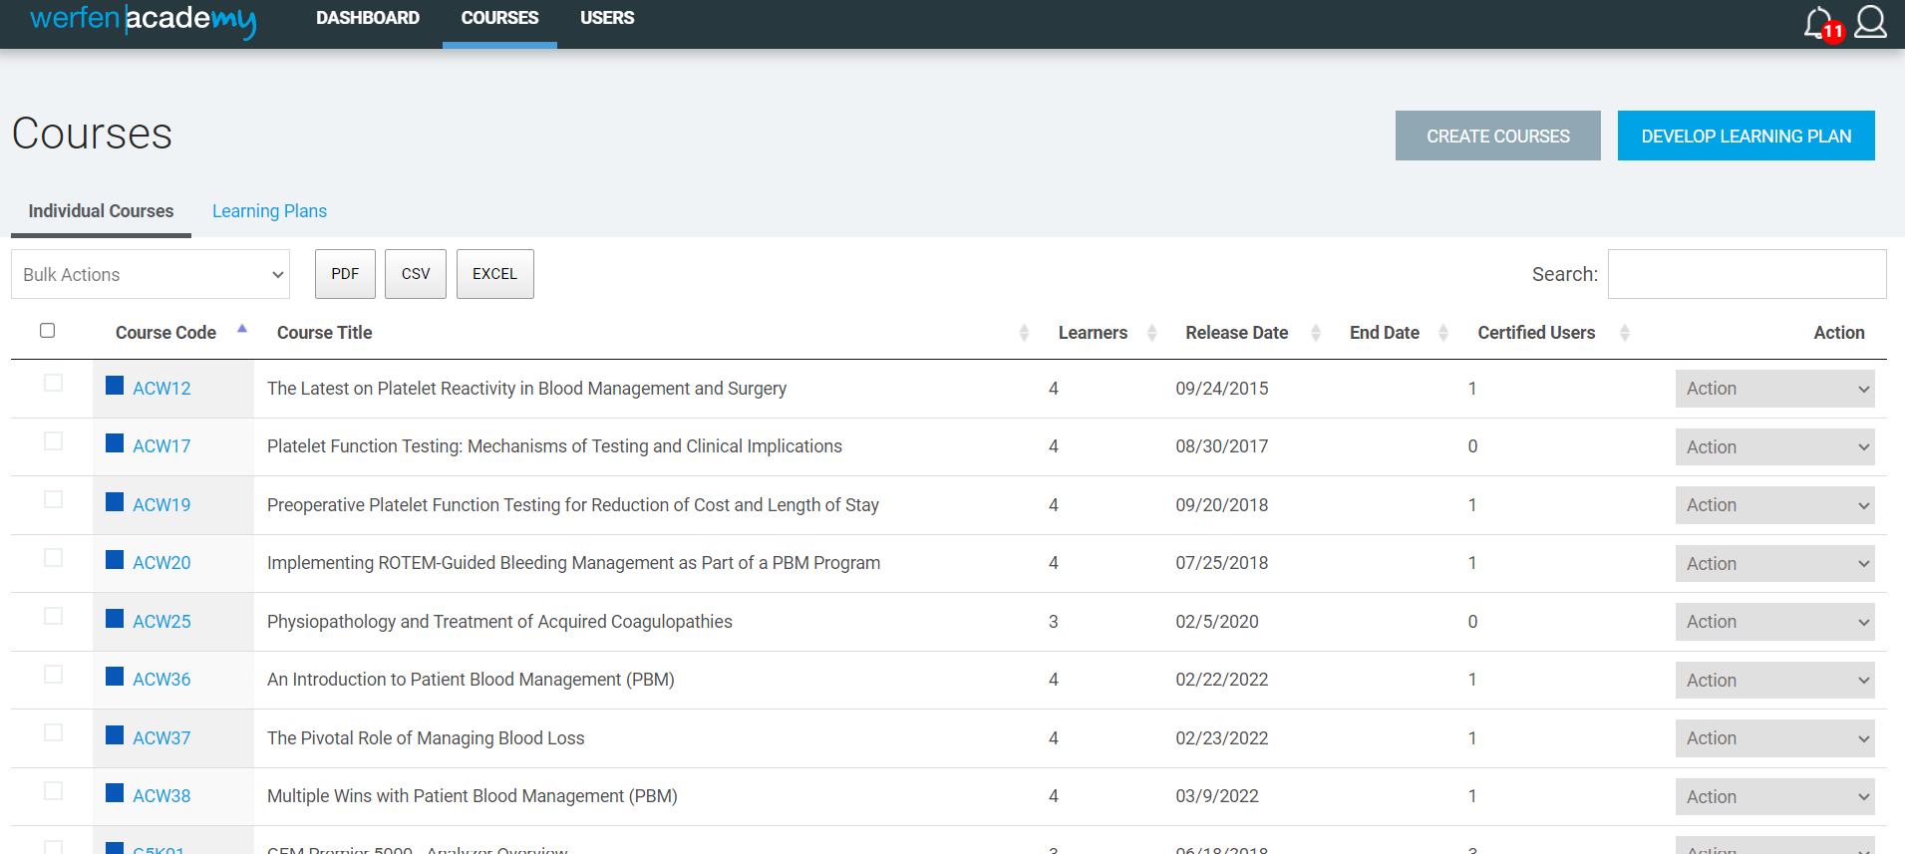
Under the courses tab, you can view and assign individual courses using the “ACTION” dropdown menu.

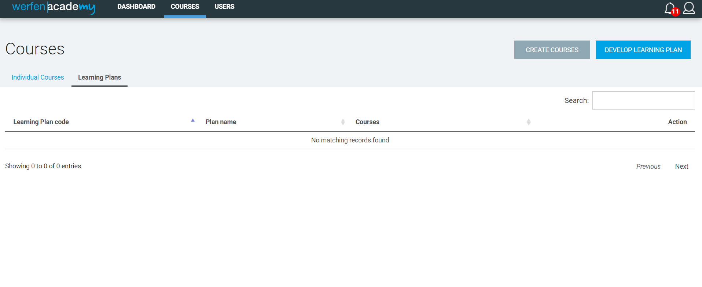
You can also develop a learning plan. To do this, click the “DEVELOP LEARNING PLAN” button.

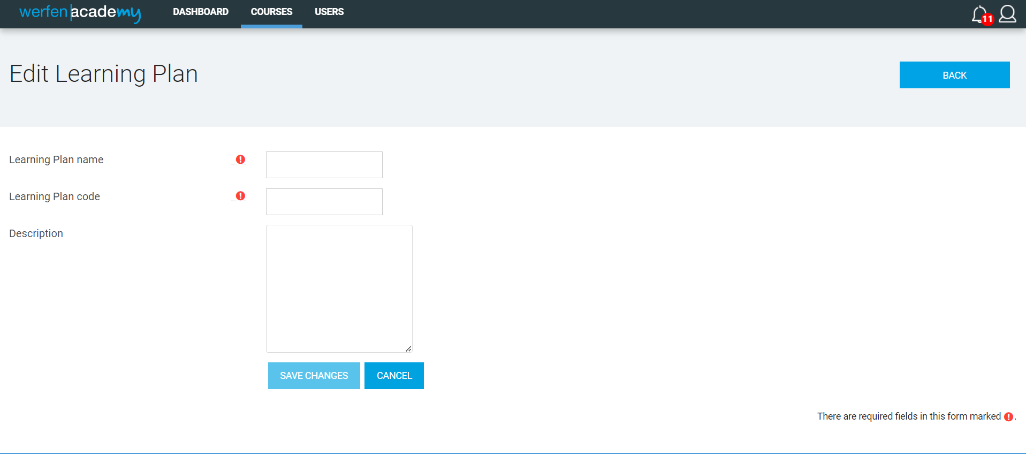
Put in a name and code, and include a short description of the plan.
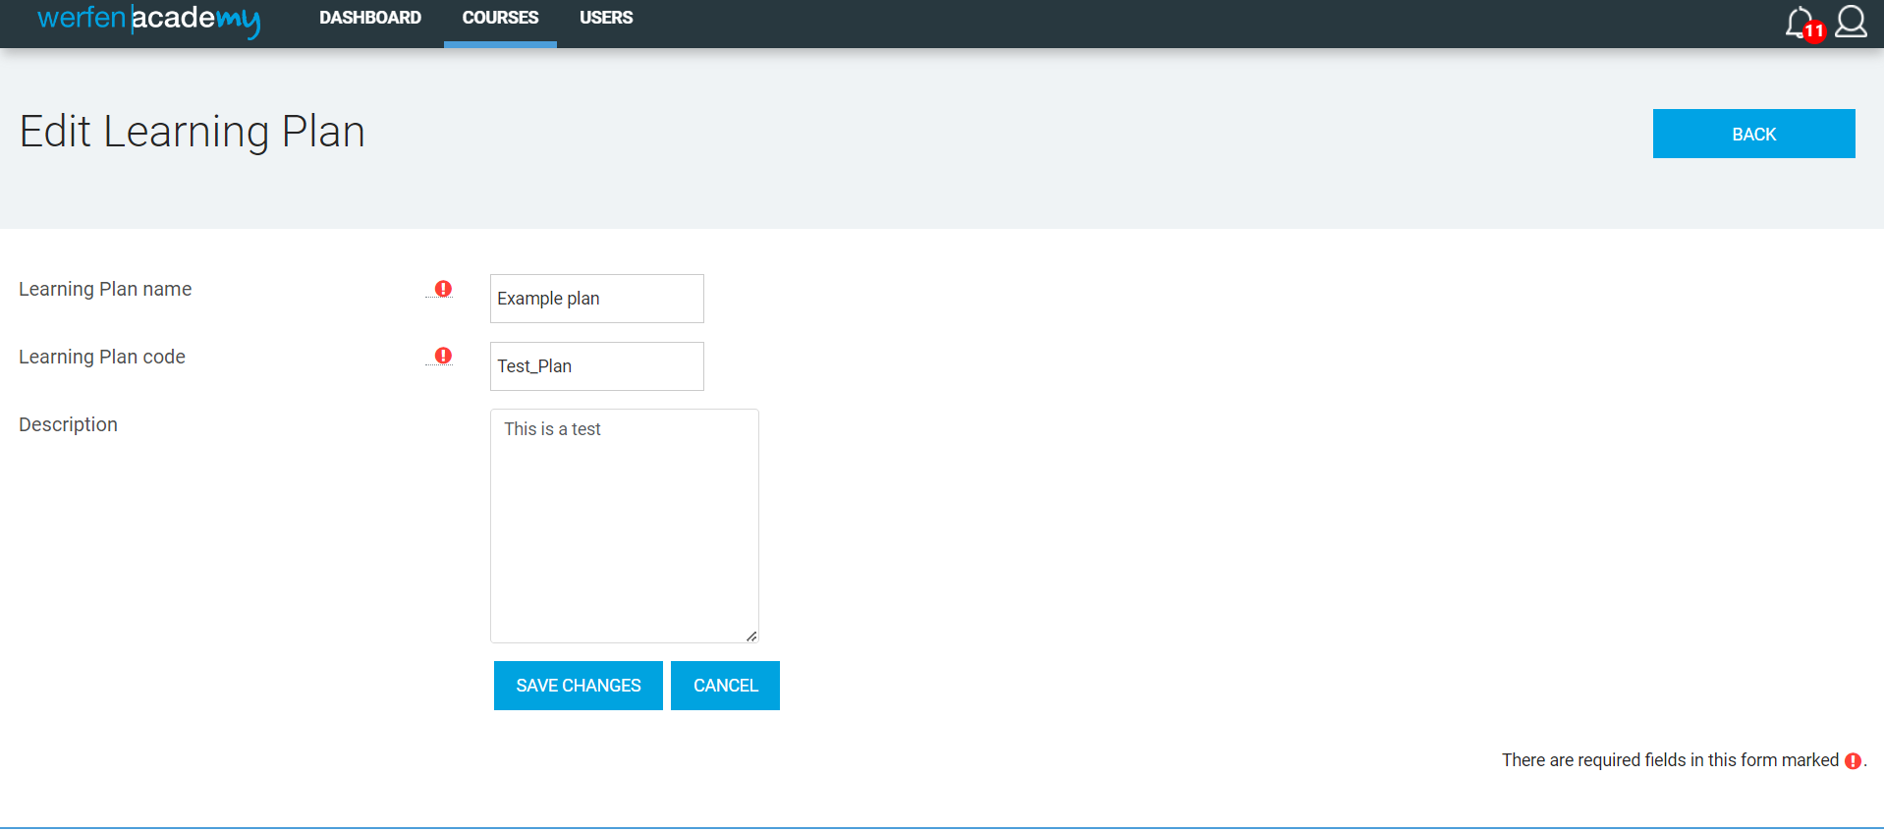
Press “SAVE CHANGES”.

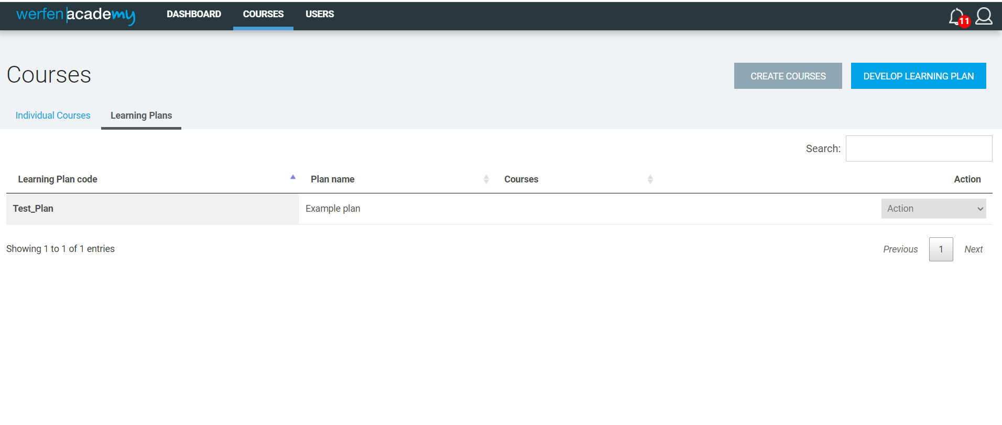
Use the action button to assign users/Teams and courses to your plan.

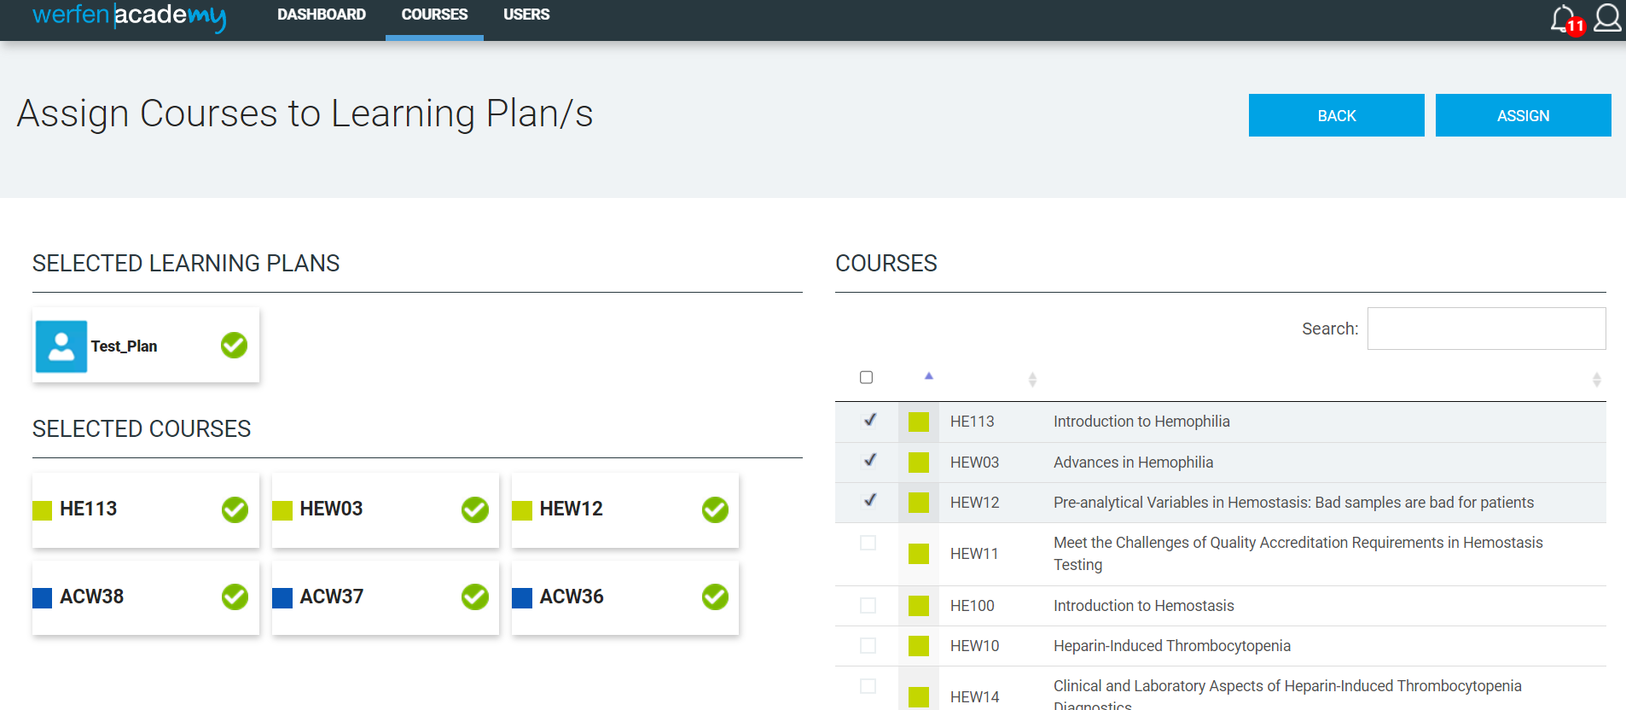

Assign courses.

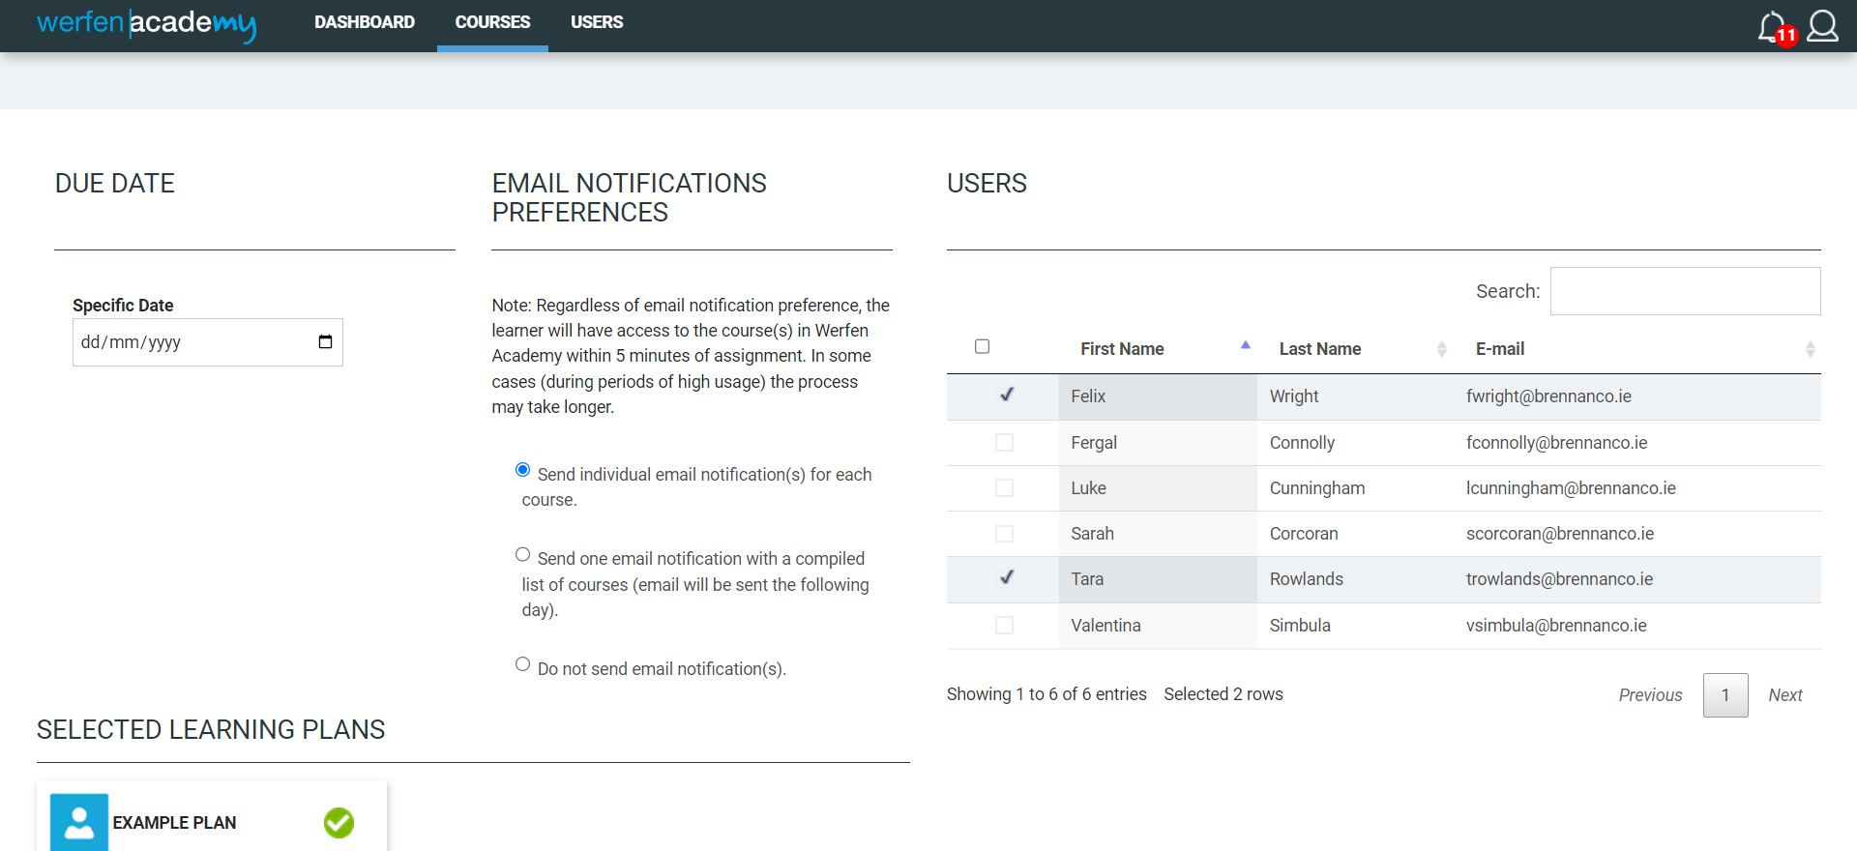
Assign users.

USERS

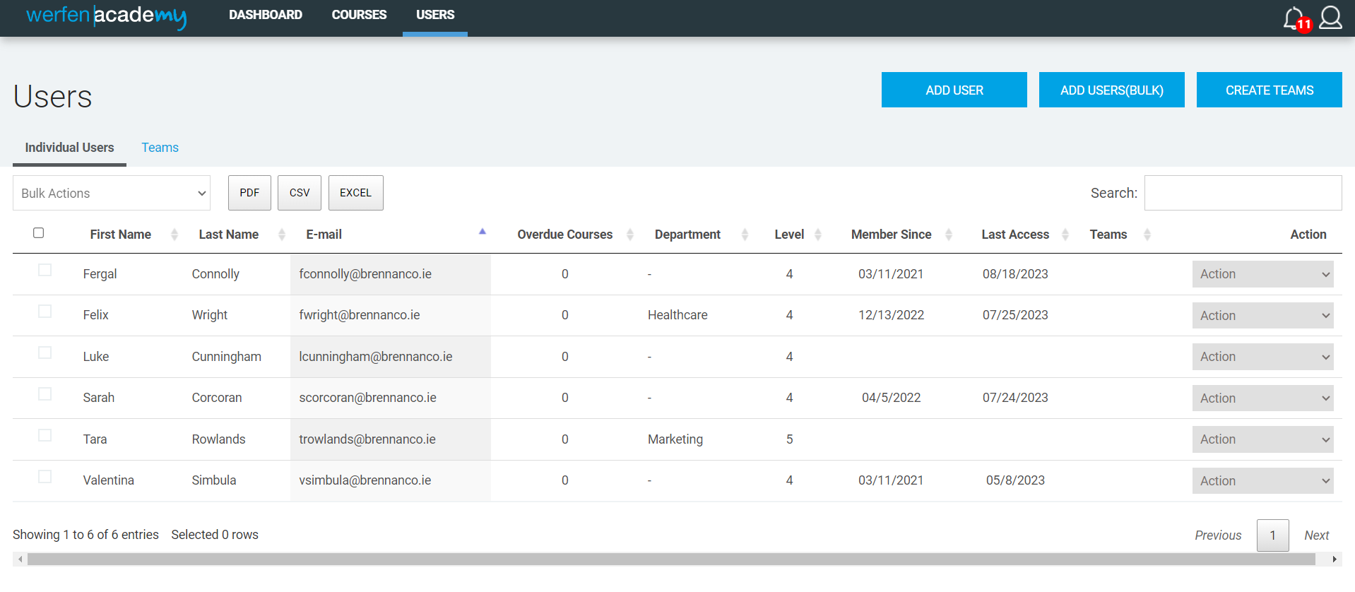
Under the user tab, you ca add a user, create a team, and manage courses assigned to each user.

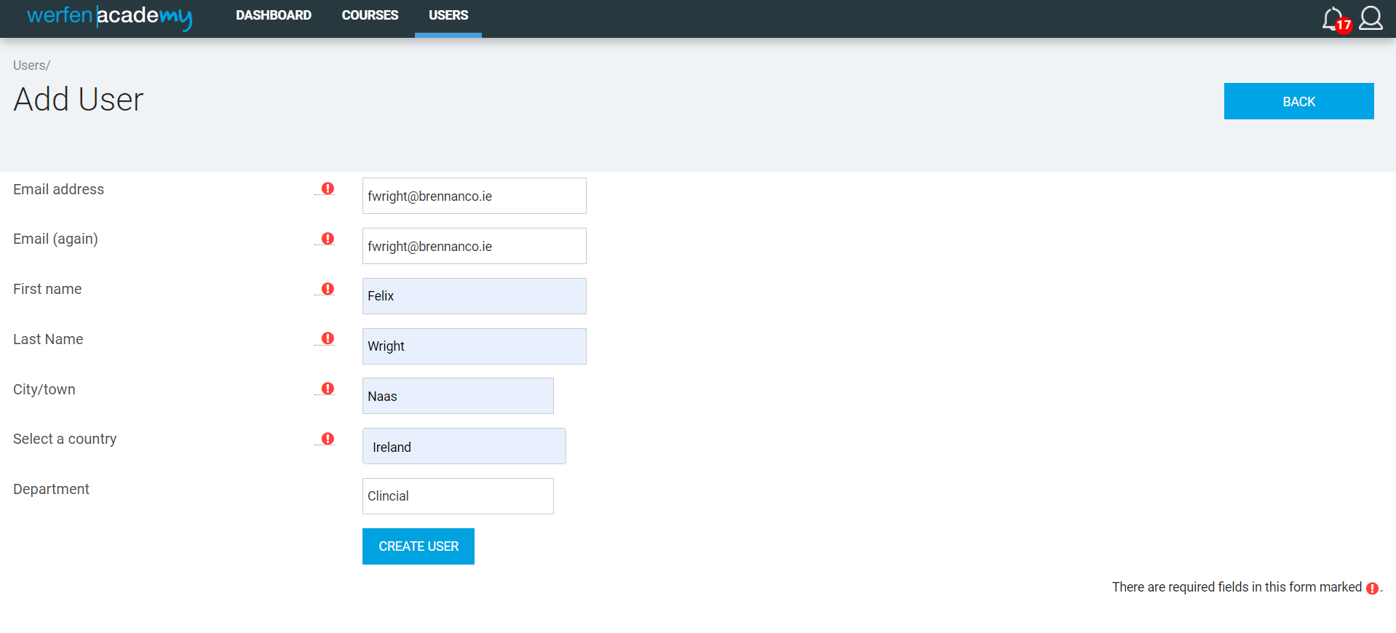
TO Add a user, select “ADD USER” button.
Input the required information, then press “CREATE USER”.

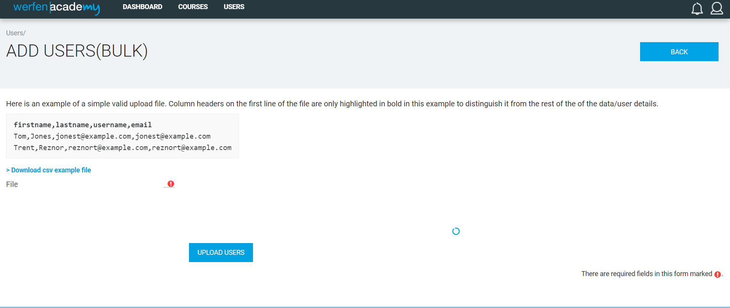
You can also bulk add users via a CSV file upload.

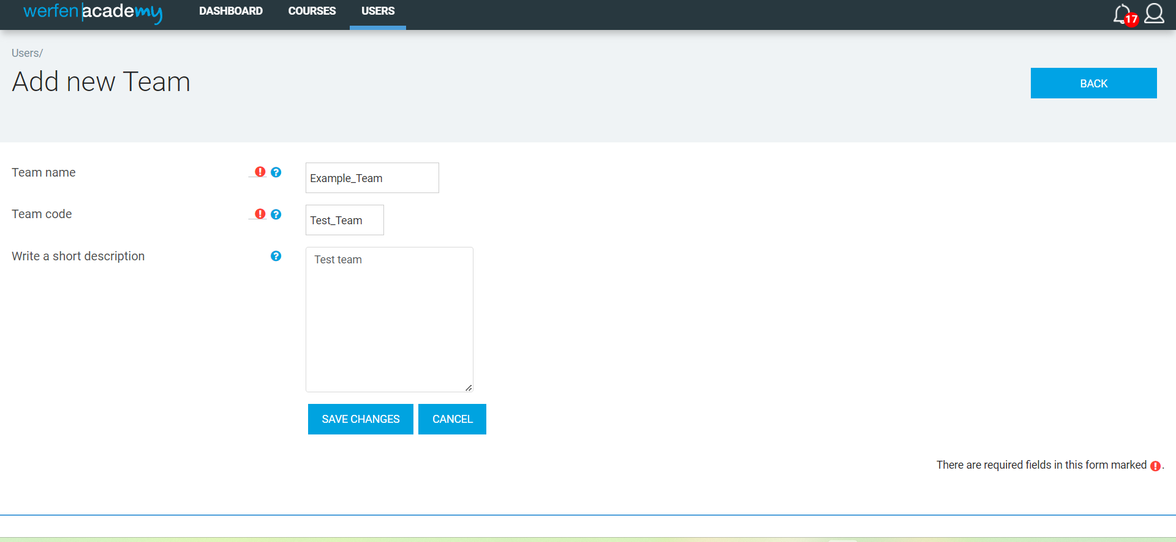
Creating a team is like creating a user group.
Insert the information and select “SAVE CHANGES”.

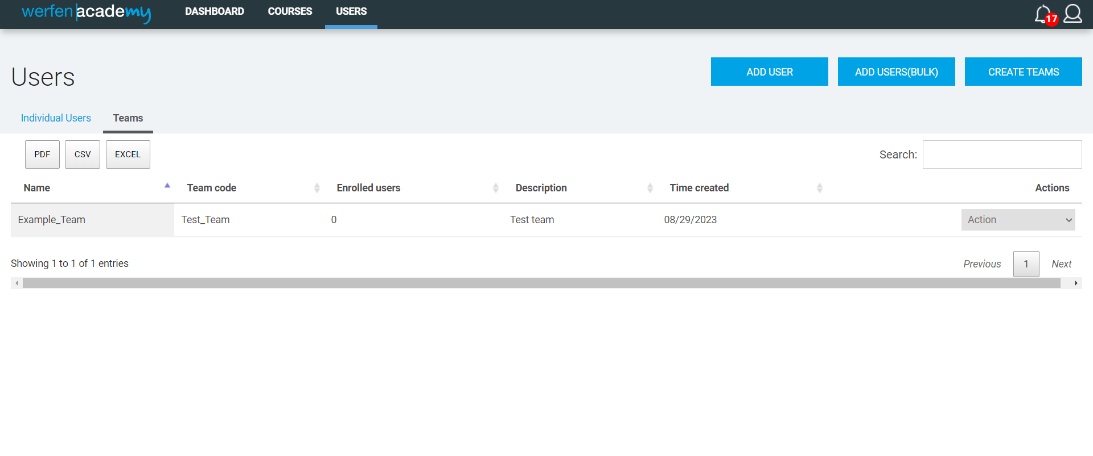
Under the action tab, you can assign users, groups, and courses to this team.

