Current Version 2 03/01/2024
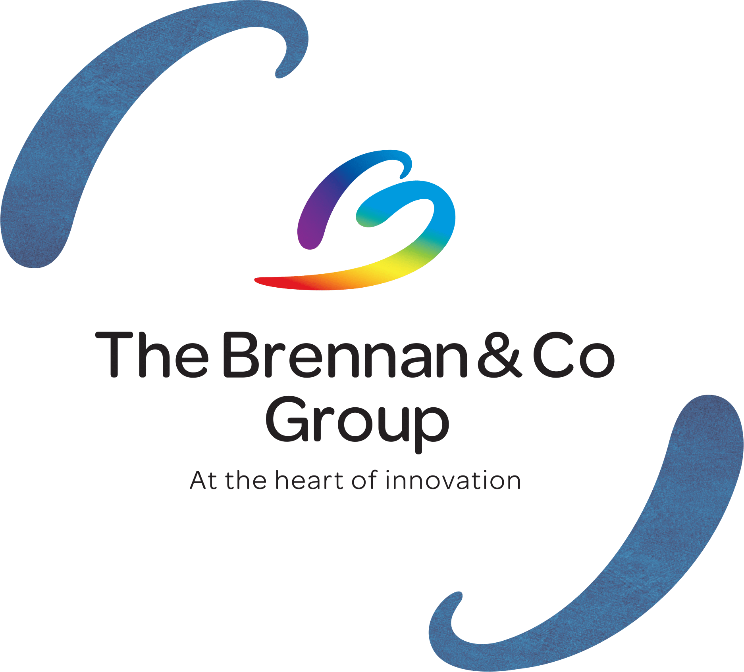
The Brennan & Co Group Environmental Policy 2024

Environmental Policy
In carrying out our operations, The Brennan & Co Group (We) acknowledges that our activities impact the environment. We recognise that we have a responsibility to demonstrate sound environmental awareness, management and sustainability through the implementation of best practice.
We further understand the importance of being proactive in addressing these environmental sustainability challenges, and we are committed to working diligently to achieve our goals.
This environmental policy statement has been developed to cover all of our sites in Dublin, Galway and Belfast.
We aim to monitor and work to reduce our environmental impacts through measures in the following areas:

Waste & Water Management
- Minimising waste by reduced consumption and operation of effective and environmentally sound waste management and recycling procedures.
Our Waste Management policy is available on request.
- We are also members of Repak (https://repak.ie/about-us/) and the WEEE and Battery Compliance Scheme (https://erp-recycling.org/) – certificates available on request.

Energy consumption and GHGs
- Reducing energy use through effective education and awareness and the installation of energy efficient technology where appropriate;
- Regular review of our Improvement Plan (through our EcoMerit certification program), and continuous action to ensure timely identification of issues and appropriate improvements.
- By applying responsible purchasing methodologies which consider the environmental impacts of the products and services purchased we reduce our footprint. Where possible we even use a sustainable solution for all shipping including cold chain by using eco-friendly packaging materials and bio-based cold packs.
- Provide staff with the necessary awareness, education, training and resources to implement this policy;
- Developing environmental management action plans and regularly assessing whether the objectives and targets are being met.

Supply Chain Sustainability
Key to our sustainability policy are our strategic partnerships, with whom we work closely to reduce our environmental footprint. These partners provide a safe working environment, treat resources with respect and work in an environmentally conscious way. Our supplier onboarding process, Supplier Code of Conduct policy and Sustainability Questionnaire are key to monitoring our supply chain.

Training and development
This Environmental Policy is made available to all employees through our internal intranet and forms part of our employee induction onboarding. Through continuous innovation and collaboration, employees are encouraged to work closely with customers, suppliers and other interested parties to continually refine our work practices to meet and surpass our sustainability goals.
  - We offer environmental training courses to all employees, through our green education partner Vyra (https://vyra.com/).

Biodiversity
  - We work with our gardening team to ensure that the grounds are maintained to encourage biodiversity.
  - We partner with local community organisations to support bio-diversity efforts in our local district. Specific examples available on request.

Health & safety
Customer: Our standard operating process B&C-016 Service Calls & Preventative Maintenance details how our service team conduct installations or maintenance of equipment on customer sites and the necessity to create RAMS Risk Assessment method statement where applicable. B&C-044 details the responsible storage, handling and disposal of any chemicals' and solvents. We are also registered with the Environmental Protection Agency for regulating the use of radiation sources.
Certificate available on request.
General: Our Health & Safety policy calls out our identifies risks and mitigation. Our objective is to comply with all Health & Safety laws, reduce risk and strive to maintain an injury-free and illness-free work environment. Our in-house Health & Safety Officer is NEBOSH certified.

Environmental services and advocacy
Together with our strategic partners we recognise that circularity is a powerful strategy to reduce carbon emissions. We believe that circular business models offer significant benefits to our planet, our customers, and the societies we serve and depend on. We aim to maximise the lifetime value of our products and solutions while minimizing the use of new materials and resources and eliminating waste. We do this through innovative service models such as, smart digital solutions, and product take-back, refurbishment and recycling.
We review our key customers’ sustainability frameworks and road maps and work with them to offer more environmentally product and services. Please see customer case study. offer more environmentally product and services. Please see customer case study linked below.

Click here to view The Marlay Invisible Systems Case Study

EMS (Environmental Management System)
  - We use the EcoMerit accreditation system to monitor our environmental performance (energy efficiency and waste management). This includes a comprehensive improvement plan and annual surveillance by EcoMerit. We achieved certification in 2023 for our Dublin and Galway sites, certificates available on request. We are currently working through the certification process for our Belfast site.

Environmental Commitments
    - Reduce CO2 emissions by 7.5% year on year
Supported by our Improvement plan and calculated through our annual Ecomerit audit
    - Retain EcoMerit certification for 2023-2027
    - Improve EcoVadis ranking from Bronze to Silver by 2025
    - Target yield of 150,000kWh annually from solar panels installed at our Dublin site

This policy will be reviewed annually to ensure it continues to reflect the company’s activities as well as global trends and expectations. The Green team are responsible for the content of and operational implementation of this policy. This policy is a controlled document, any queries please contact quality@brennanco.ie

